LAB ACTIVITY – Use Case Diagram & Activity Diagram

Group No : 20 (CSE – AIE – A)

Name | Roll No
Anuvind M P | AM.EN.U4AIE22010
Girish S | AM.EN.U4AIE22044
R S Harish Kumar | AM.EN.U4AIE22042

Project Title : ASA- Autism Spectrum Analyzer

USE CASE DIAGRAM
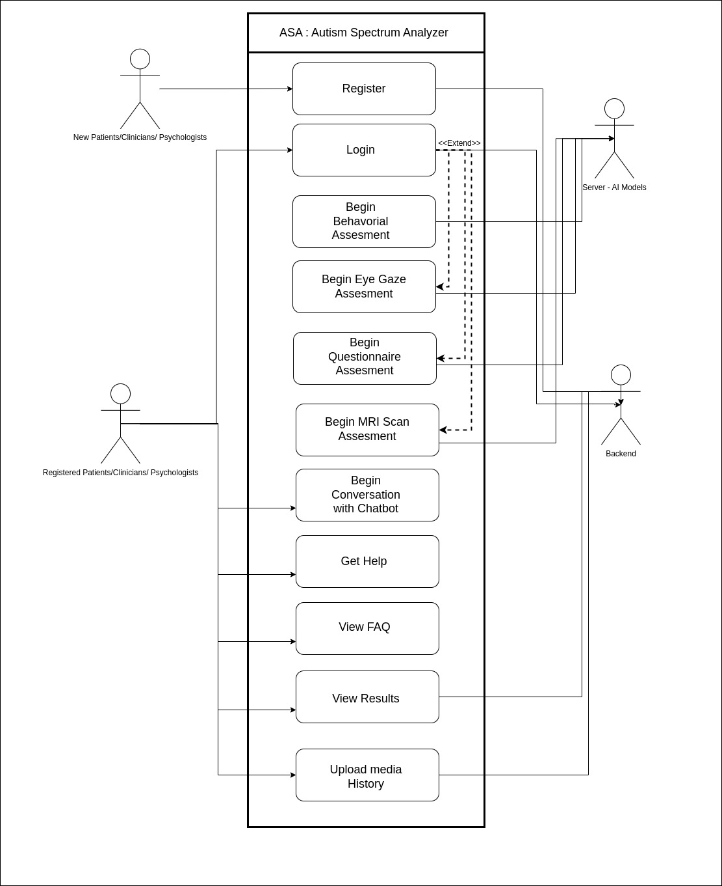

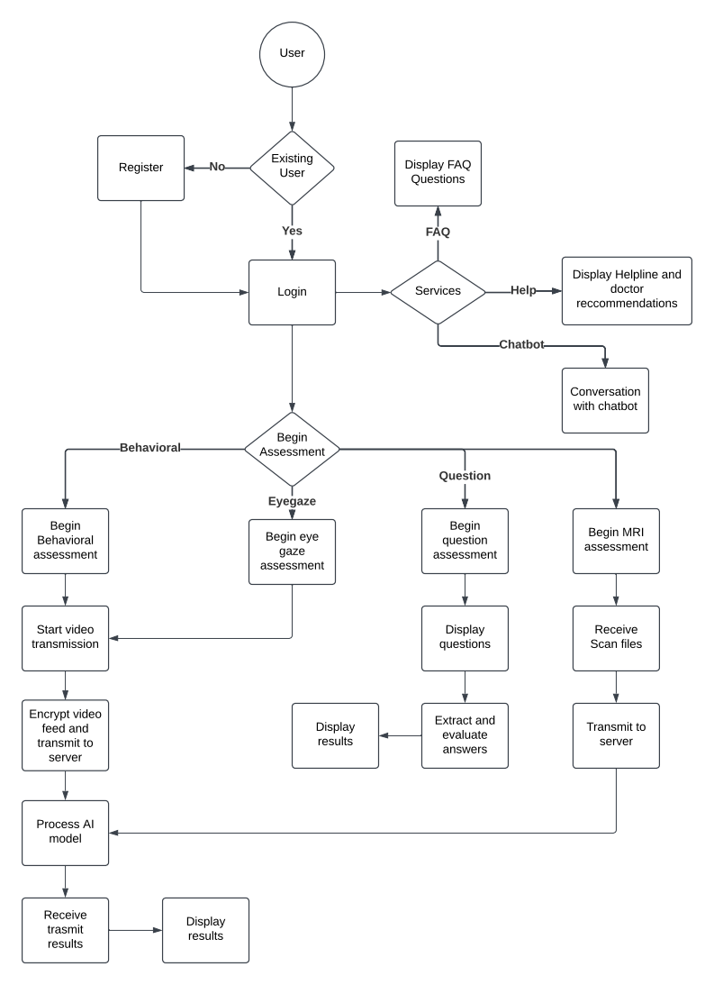
ACTIVITY DIAGRAM

